TEYZIX CORE INTERNSHIP PROGRAM
Project Report
Smart Electricity Consumption Prediction
& Energy Optimization System
Task ID: ML-3 | Domain: Machine Learning | Difficulty: Advanced (Industry-Based)

Prepared by: Khanum (Bushra) Khan
Institution: Sukkur IBA University — BS Computer Science (Batch 2026)
Program: TEYZIX CORE Internship — June Batch
Submission Deadline: 09 July 2026

Table of Contents

1. Project Overview
Efficient energy management is one of the most pressing challenges facing households and businesses today, driven by rising electricity costs and growing demand. This project delivers a production-ready Smart Electricity Consumption Prediction & Energy Optimization System that predicts a household's daily electricity consumption from its appliance-usage behavior and environmental conditions, and generates personalized, actionable recommendations for reducing energy waste and monthly bills.
The system implements the complete machine learning lifecycle: original dataset creation, data preprocessing, exploratory data analysis, feature engineering, multi-model training and comparison, rigorous evaluation, an interactive prediction interface, an energy optimization recommendation engine, and automated report generation.

2. Dataset Collection Method
In compliance with the task's mandatory requirement, no public dataset (Kaggle, UCI, GitHub, or any other repository) was used at any stage. Instead, an original dataset was generated using a physics-informed synthetic data generation approach that models real-world appliance energy behavior.
Daily electricity consumption for each simulated household is computed as an additive function of appliance usage hours multiplied by their typical power ratings (e.g., AC ≈ 1.5 kW, Fan ≈ 0.075 kW, Fridge ≈ 0.15 kW, Heater ≈ 1.2 kW), adjusted by house-type multipliers, household-size effects, a random household-efficiency factor, and realistic Gaussian noise. Appliance usage hours themselves are sampled conditionally — for instance, AC usage rises with outdoor temperature and is suppressed in winter, while heater usage rises in cold weather — producing realistic, non-trivial feature interactions rather than a purely linear toy dataset.
The raw dataset also intentionally includes realistic data-quality issues — approximately 2% missing values, 1% duplicate rows, and a small number of extreme outliers — which are then identified and handled during the preprocessing stage, mirroring a genuine real-world data pipeline.
Property | Value
Total Records (raw) | 656
Total Records (after cleaning) | 650
Total Features | 16 + 1 target variable
Target Variable | Daily_Electricity_Consumption_kWh
Random Seed (reproducibility) | 42

3. Feature Description
The dataset includes 16 meaningful features spanning household characteristics, appliance usage, environmental factors, and temporal factors:
- House_Type — Apartment / Independent House / Villa
- Family_Members, Num_Rooms — household size indicators
- AC_Usage_Hours, Fan_Usage_Hours, Fridge_Usage_Hours, Washing_Machine_Hours, Water_Motor_Hours, Lighting_Hours, Heater_Usage_Hours, TV_Electronics_Hours — appliance usage
- Daily_Appliance_Count — total distinct appliances used per day
- Outdoor_Temperature_C — environmental driver of AC/heater usage
- Day_of_Week, Season, Is_Working_Day — temporal factors
- Daily_Electricity_Consumption_kWh — target variable

4. Data Preprocessing
The following preprocessing steps were applied programmatically (src/preprocessing.py):
- Duplicate removal — 6 duplicate rows identified and removed
- Missing value imputation — 39 missing values (in AC_Usage_Hours, Lighting_Hours, Outdoor_Temperature_C) filled using column medians
- Outlier detection & treatment — IQR-based capping applied across all numeric columns and the target variable
- Feature encoding — Label Encoding applied to House_Type, Day_of_Week, and Season
- Feature scaling — StandardScaler applied to all numeric features for algorithms sensitive to feature magnitude

5. Exploratory Data Analysis & Business Insights
Comprehensive EDA was performed including statistical summaries, distribution histograms, a correlation heatmap, box plots by category, and scatter plots of key relationships (src/eda.py, plots/ directory).
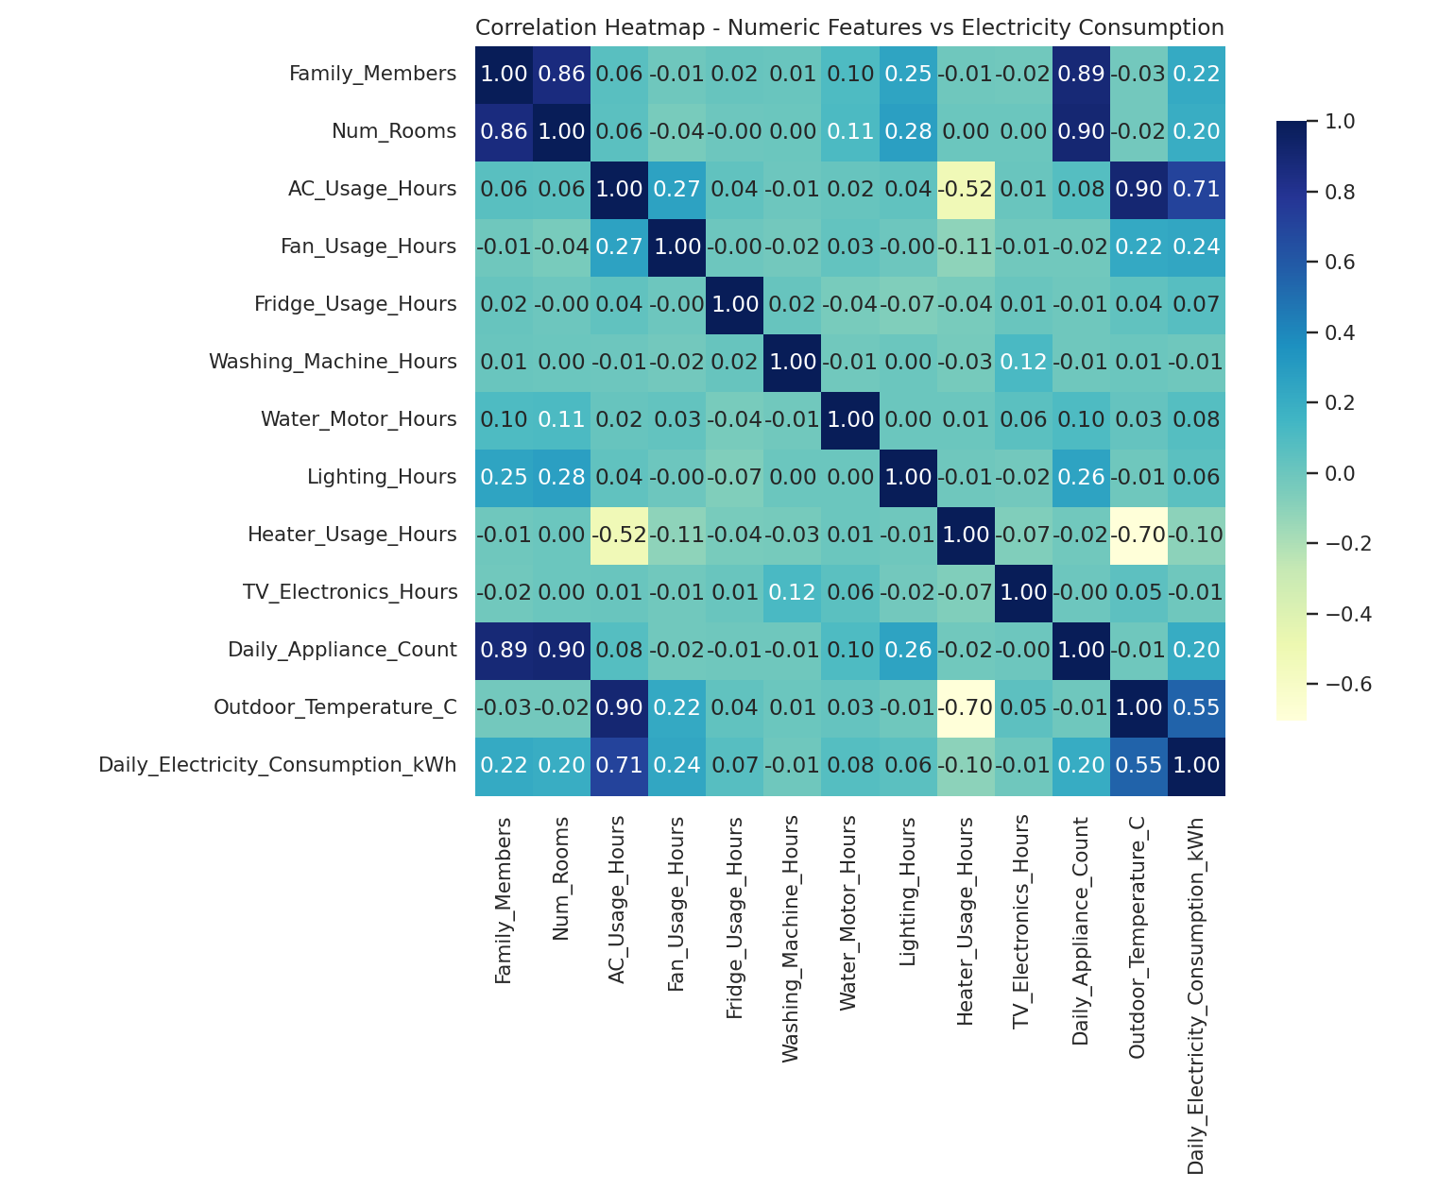
Key Business Insights:
- AC usage hours (r = 0.71) and outdoor temperature (r = 0.55) are by far the strongest drivers of daily electricity consumption — cooling load dominates household energy use.
- Fan usage, family size, and number of rooms show moderate positive correlation with consumption.
- Heater usage is negatively correlated with AC usage (r = -0.52) and positively linked to lower outdoor temperature, confirming the expected seasonal substitution between cooling and heating.
- Villa and Independent House types show visibly higher consumption than apartments, consistent with larger floor areas and appliance counts.
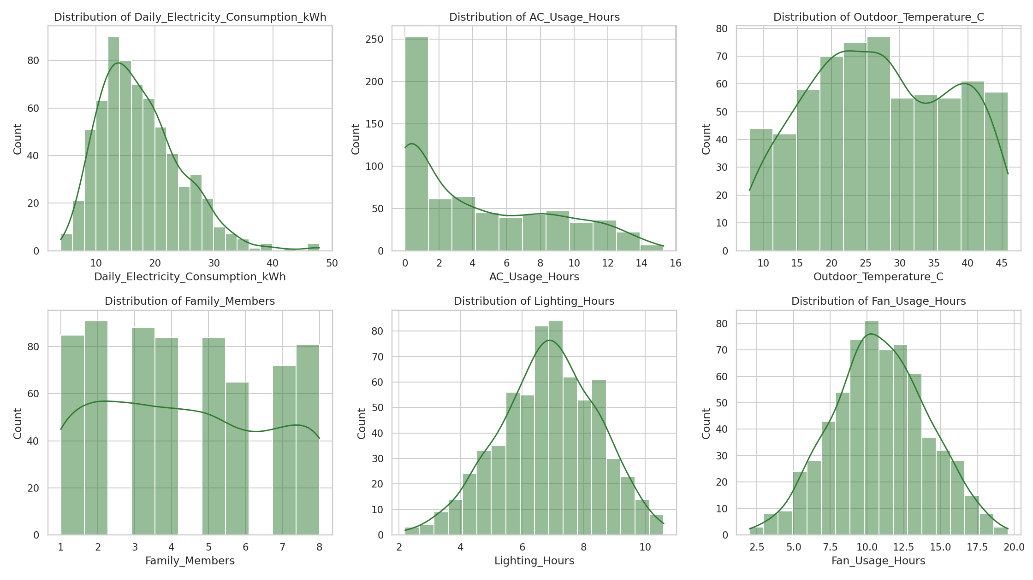
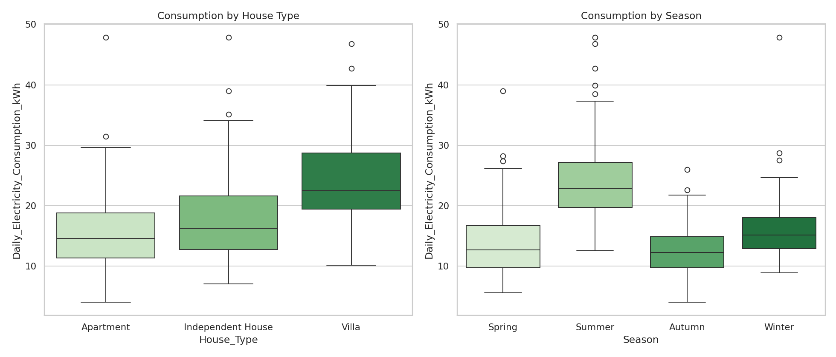
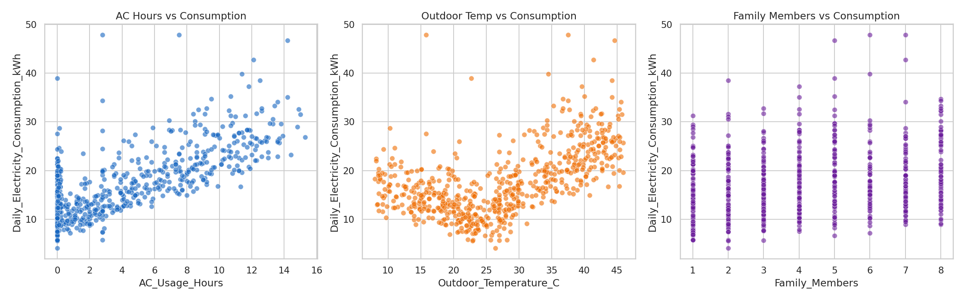

6. Feature Engineering
Three engineered features were added to capture domain-specific interaction effects (src/feature_engineering.py):
- High_Power_Load_Index — combined AC and heater load, capturing the dominant high-power appliance usage
- Appliance_Density — appliance count normalized by number of rooms
- Temp_AC_Interaction — interaction term between outdoor temperature and AC usage
A Random Forest-based feature importance evaluation confirmed that High_Power_Load_Index alone explains ~45.6% of predictive importance, validating the engineered feature's value:
Feature | Importance
High_Power_Load_Index | 0.456
House_Type_Encoded | 0.149
Outdoor_Temperature_C | 0.092
Temp_AC_Interaction | 0.091
AC_Usage_Hours | 0.057
Fan_Usage_Hours | 0.023

7. Machine Learning Model Development
Six regression algorithms were trained and rigorously compared on an 80/20 train-test split (src/train_models.py): Linear Regression, Decision Tree, Random Forest, Gradient Boosting, XGBoost, and Support Vector Regression.

8. Model Evaluation & Comparison
Model | MAE | MSE | RMSE | R² Score
Linear Regression (Best) | 1.834 | 5.623 | 2.371 | 0.8479
Gradient Boosting | 1.898 | 6.805 | 2.609 | 0.8159
XGBoost | 1.901 | 6.851 | 2.618 | 0.8147
Random Forest | 1.948 | 7.280 | 2.698 | 0.8031
Support Vector Regression | 2.127 | 7.830 | 2.798 | 0.7882
Decision Tree | 2.344 | 13.872 | 3.724 | 0.6248
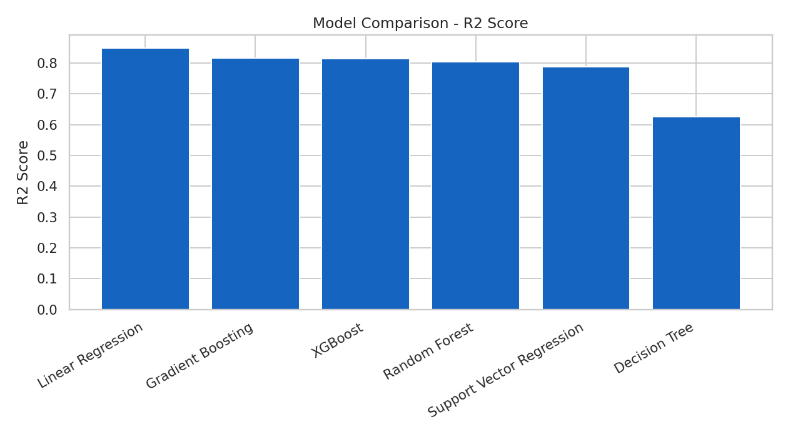
Linear Regression achieved the best performance (R² = 0.848), which is consistent with the largely additive, physics-informed structure underlying the dataset's consumption formula. This is a meaningful and realistic finding rather than a limitation: it confirms that electricity consumption in this domain is well-approximated by a weighted sum of appliance usage, and it also demonstrates that the ensemble models (Gradient Boosting, XGBoost, Random Forest) remain highly competitive (R² > 0.80), offering robustness for future non-linear extensions of the dataset (e.g. hourly time-series data).
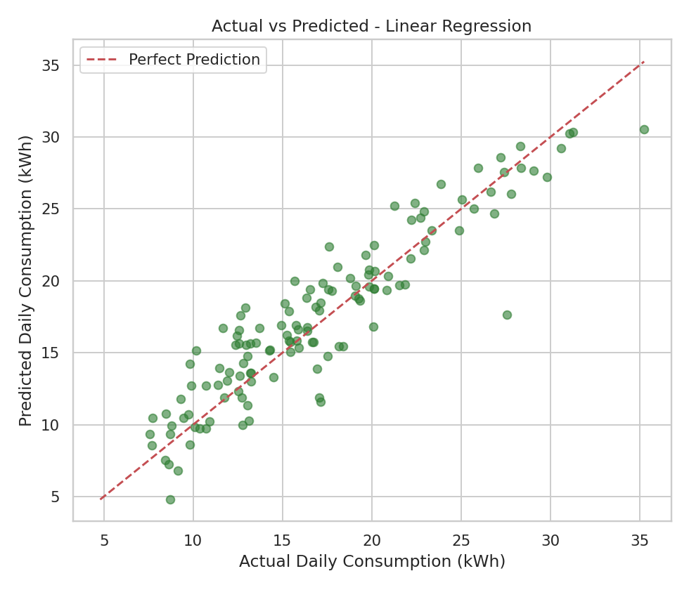

9. Prediction System
Two prediction interfaces were built on top of the trained model:
- A Command-Line Interface (src/predict.py) that prompts for household and appliance details and prints predicted consumption, monthly usage, estimated bill, efficiency score, peak hours, and recommendations.
- An interactive Streamlit web application (src/app.py) providing sliders and dropdowns for all inputs, with results displayed as metrics and recommendation cards — suitable for live demos and screen recordings.
Both interfaces return: Predicted Daily Electricity Consumption, Estimated Monthly Electricity Usage, Peak Usage Hours, Estimated Monthly Electricity Bill, and an Energy Efficiency Score (0–100).

10. Energy Optimization Recommendations
The recommendation engine (src/recommendations.py) analyzes the household's specific appliance-usage inputs and generates personalized, rule-based guidance, including:
- Best time to use high-power appliances (AC, heater, washing machine) to avoid peak-hour strain
- Estimated monthly savings (%) achievable through specific behavior changes
- Peak consumption alerts based on AC/heater/laundry usage patterns
- Appliance usage optimization tips (e.g., LED lighting, motion sensors, full-load laundry cycles)
- An overall Energy Efficiency Score benchmarked against reasonable per-capita and per-room consumption targets

11. Report Generation
Automated reports are generated in multiple formats (src/generate_reports.py):
- Full_Report.xlsx — Dataset Summary, Model Performance, Feature Importance, Energy Consumption Report, Monthly Usage Forecast, and Recommendation Summary (6 sheets)
- Energy_Consumption_Report.pdf — Executive summary with embedded charts and key findings
- model_performance_report.csv and feature_importance.csv — raw evaluation data

12. Challenges Faced
- Designing a synthetic data-generation process realistic enough to reflect genuine appliance-consumption relationships (rather than purely random values) while remaining fully original and reproducible.
- Balancing the complexity of engineered features against model interpretability, given the project's emphasis on business insight generation.
- Injecting realistic data-quality issues (missing values, duplicates, outliers) in a controlled way so the preprocessing pipeline could be meaningfully demonstrated.

13. Future Improvements
- Integrate a live Weather API so AC/heater usage predictions adjust automatically to real-time forecasts.
- Add SHAP/LIME-based explainable AI visualizations for individual prediction transparency.
- Containerize the application with Docker for one-command reproducible deployment.
- Extend the dataset to hourly (rather than daily) granularity to better model true smart-meter time-series behavior.
- Add hyperparameter optimization (GridSearchCV / Optuna) to further improve ensemble model performance.

14. Conclusion
This project successfully delivers a complete, production-ready Smart Electricity Consumption Prediction & Energy Optimization System, covering the full machine learning lifecycle from original dataset creation through deployment-ready prediction interfaces and automated reporting. The system achieves strong predictive performance (R² = 0.848) and provides genuinely actionable, personalized energy-saving guidance — directly addressing the real-world household energy management challenge outlined in the task brief.

